**Assignment -2**

Data Visualization and Pre-processing

|  |  |
| --- | --- |
| Assignment Date | 30 september 2022 |
| Student Name | Mathimithran T |
| Student Roll Number | 310819104711 |
| Maximum Marks | 2 Marks |

ASSIGNMENT 2

# Importing libraries

import numpy as np import pandas as pd import seaborn as sns

import matplotlib.pyplot as plt

# Loading data set

ds=pd.read_csv('Churn_Modelling.csv') ds.shape

(10000, 14)

ds.head()

|  |  |  |  |  |  |  |  |  |  |  |
| --- | --- | --- | --- | --- | --- | --- | --- | --- | --- | --- |
| \ | RowNumber | | CustomerId | | Surname | CreditScore | Geography | Gender | | Age |
| 0 | 1 | | 15634602 | | Hargrave | 619 | France | Female | | 42 |
| 1 | 2 | | 15647311 | | Hill | 608 | Spain | Female | | 41 |
| 2 | 3 | | 15619304 | | Onio | 502 | France | Female | | 42 |
| 3 | 4 | | 15701354 | | Boni | 699 | France | Female | | 39 |
| 4 | 5 | | 15737888 | | Mitchell | 850 | Spain | Female | | 43 |
|  | Tenure | Balance | | NumOfProducts | | HasCrCard | IsActiveMember | | \ | |
| 0 | 2 | 0.00 | | 1 | | 1 | 1 | |  | |
| 1 | 1 | 83807.86 | | 1 | | 0 | 1 | |  | |
| 2 | 8 | 159660.80 | | 3 | | 1 | 0 | |  | |
| 3 | 1 | 0.00 | | 2 | | 0 | 0 | |  | |
| 4 | 2 | 125510.82 | | 1 | | 1 | 1 | |  | |
|  | EstimatedSalary | | | Exited | | | | | | |
| 0 | 101348.88 | | | 1 | | | | | | |
| 1 | 112542.58 | | | 0 | | | | | | |
| 2 | 113931.57 | | | 1 | | | | | | |
| 3 | 93826.63 | | | 0 | | | | | | |
| 4 | 79084.10 | | | 0 | | | | | | |

# Visualization

## Univariate

sns.distplot(ds['EstimatedSalary'],hist=True)

/usr/local/lib/python3.7/dist-packages/seaborn/distributions.py:2619: FutureWarning: `distplot` is a deprecated function and will be removed in a future version. Please adapt your code to use either `displot` (a figure-level function with similar flexibility) or `histplot` (an

axes-level function for histograms). warnings.warn(msg, FutureWarning)

<matplotlib.axes._subplots.AxesSubplot at 0x7f8afae88250>

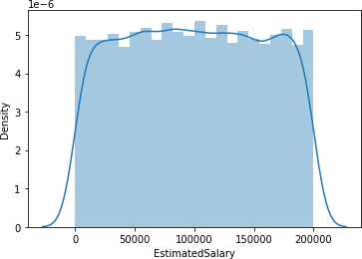

## Bivariate

sns.relplot(x='Age',y='Balance',data=ds)

<seaborn.axisgrid.FacetGrid at 0x7f8afaaa3dd0>

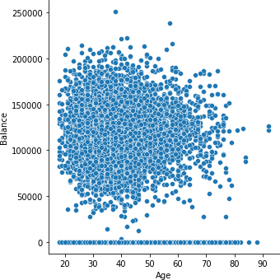

sns.catplot(x='Geography',y='CreditScore',data=ds)

<seaborn.axisgrid.FacetGrid at 0x7f8afae83dd0>

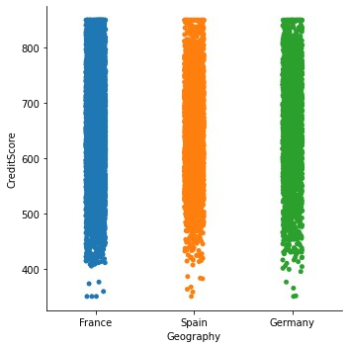

## Multivariate

sns.relplot(x='Age',y='Balance',hue='Geography',data=ds)

<seaborn.axisgrid.FacetGrid at 0x7f8af64e6610>

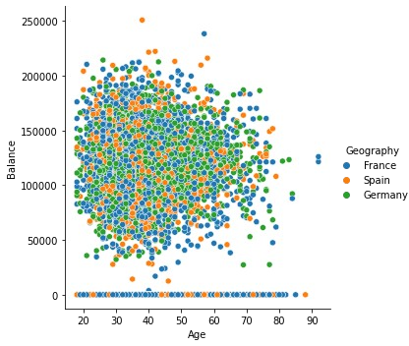

sns.boxplot(x='Exited',y='CreditScore',hue='Gender',data=ds)

<matplotlib.axes._subplots.AxesSubplot at 0x7f8af64ae810>

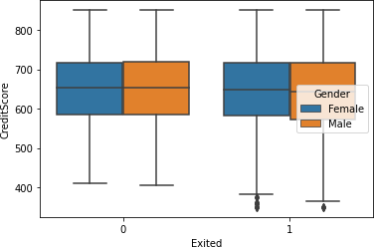

# Descriptive Statistics

ds.describe()

|  |  |  |  |  |  |  |
| --- | --- | --- | --- | --- | --- | --- |
| RowNumber  Tenure \ | | CustomerId | CreditScore | | Age | |
| count 10000.00000  10000.000000  mean 5000.50000 | | 1.000000e+04  1.569094e+07 | 10000.000000  650.528800 | | 10000.000000  38.921800 | |
| 5.012800  std 2886.89568 | | 7.193619e+04 | 96.653299 | | 10.487806 | |
| 2.892174  min 1.00000 | | 1.556570e+07 | 350.000000 | | 18.000000 | |
| 0.000000 | |  |  | |  | |
| 25% 2500.75000 | | 1.562853e+07 | 584.000000 | | 32.000000 | |
| 3.000000 | |  |  | |  | |
| 50% 5000.50000 | | 1.569074e+07 | 652.000000 | | 37.000000 | |
| 5.000000 | |  |  | |  | |
| 75% 7500.25000 | | 1.575323e+07 | 718.000000 | | 44.000000 | |
| 7.000000  max 10000.00000 | | 1.581569e+07 | 850.000000 | | 92.000000 | |
| 10.000000 | |  |  | |  | |
|  | Balance | NumOfProducts | | HasCrCard | IsActiveMember | \ |
| count | 10000.000000 | 10000.000000 | | 10000.00000 | 10000.000000 |  |
| mean | 76485.889288 | 1.530200 | | 0.70550 | 0.515100 |  |
| std | 62397.405202 | 0.581654 | | 0.45584 | 0.499797 |  |
| min | 0.000000 | 1.000000 | | 0.00000 | 0.000000 |  |
| 25% | 0.000000 | 1.000000 | | 0.00000 | 0.000000 |  |

|  |  |  |  |  |
| --- | --- | --- | --- | --- |
| 50% | 97198.540000 | 1.000000 | 1.00000 | 1.000000 |
| 75% | 127644.240000 | 2.000000 | 1.00000 | 1.000000 |
| max | 250898.090000 | 4.000000 | 1.00000 | 1.000000 |
|  | EstimatedSalary | Exited | | |
| count | 10000.000000 | 10000.000000 | | |
| mean | 100090.239881 | 0.203700 | | |
| std | 57510.492818 | 0.402769 | | |
| min | 11.580000 | 0.000000 | | |
| 25% | 51002.110000 | 0.000000 | | |
| 50% | 100193.915000 | 0.000000 | | |
| 75% | 149388.247500 | 0.000000 | | |
| max | 199992.480000 | 1.000000 | | |

# Handling the missing(null) values

ds.isnull().any()

RowNumber False

CustomerId False

Surname False

CreditScore False

Geography False

Gender False

Age False

Tenure False

Balance False

NumOfProducts False

HasCrCard False

IsActiveMember False EstimatedSalary False Exited False

dtype: bool ds.isnull().sum()

RowNumber 0

CustomerId 0

Surname 0

CreditScore 0

Geography 0

Gender 0

Age 0

Tenure 0

Balance 0

NumOfProducts 0

HasCrCard 0

IsActiveMember 0

EstimatedSalary 0

Exited 0

dtype: int64

# Split the data into dependent and independent variables

x=ds.iloc[:,3:13].values print(x.shape) y=ds.iloc[:,13:14].values print(y.shape)

(10000, 10)

(10000, 1)

# Finding and Replacing Outliers

ds.skew()

/usr/local/lib/python3.7/dist-packages/ipykernel_launcher.py:1: FutureWarning: Dropping of nuisance columns in DataFrame reductions (with 'numeric_only=None') is deprecated; in a future version this will raise TypeError. Select only valid columns before calling the reduction.

"""Entry point for launching an IPython kernel.

|  |  |
| --- | --- |
| RowNumber | 0.000000 |
| CustomerId | 0.001149 |
| CreditScore | -0.071607 |
| Age | 1.011320 |
| Tenure | 0.010991 |
| Balance | -0.141109 |
| NumOfProducts | 0.745568 |
| HasCrCard | -0.901812 |
| IsActiveMember | -0.060437 |
| EstimatedSalary | 0.002085 |
| Exited | 1.471611 |
| dtype: float64 |  |

sns.boxplot(ds["Age"])

/usr/local/lib/python3.7/dist-packages/seaborn/_decorators.py:43: FutureWarning: Pass the following variable as a keyword arg: x. From version 0.12, the only valid positional argument will be `data`, and passing other arguments without an explicit keyword will result in an error or misinterpretation.

FutureWarning

<matplotlib.axes._subplots.AxesSubplot at 0x7f8af6283850>

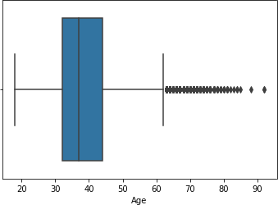

q0 = ds["Age"].describe()["25%"]

q1 = ds["Age"].describe()["75%"] iqr=q1-q0

lb = q0 -(1.5*iqr) ub = q1 + (1.5*iqr)

ds[ds["Age"]<lb] Empty DataFrame

Columns: [RowNumber, CustomerId, Surname, CreditScore, Geography,

Gender, Age, Tenure, Balance, NumOfProducts, HasCrCard, IsActiveMember, EstimatedSalary, Exited]

Index: [] ds[ds["Age"]>ub]

RowNumber CustomerId Surname CreditScore Geography Gender Age \

|  |  |  |  |  |  |  |  |  |
| --- | --- | --- | --- | --- | --- | --- | --- | --- |
| 58 |  |  | 59 | 15623944 | T'ien | 511 | Spain |  |
| Female |  | 66 |  |  |  |  |  |  |
| 85 |  |  | 86 | 15805254 | Ndukaku | 652 | Spain |  |
| Female |  | 75 |  |  |  |  |  |  |
| 104 |  |  | 105 | 15804919 | Dunbabin | 670 | Spain |  |
| Female |  | 65 |  |  |  |  |  |  |
| 158 |  |  | 159 | 15589975 | Maclean | 646 | France |  |
| Female |  | 73 |  |  |  |  |  |  |
| 181 |  |  | 182 | 15789669 | Hsia | 510 | France |  |
| Male | 65 |  |  |  |  |  |  |  |
| ... |  |  | ... | ... | ... | ... | ... | .. |

|  |  |  |  |  |  |  |  |  |  |  |
| --- | --- | --- | --- | --- | --- | --- | --- | --- | --- | --- |
| . ... 9753 |  | 9754 | | 15705174 | | Chiedozie | 656 | | Germany | |
| Male 9765 | 68 | 9766 | | 15777067 | | Thomas | 445 | | France | |
| Male 9832 | 64 | 9833 | | 15814690 | | Chukwujekwu | 595 | | Germany | |
| Female |  | 64 | |  | |  |  | |  | |
| 9894 |  | 9895 | | 15704795 | | Vagin | 521 | | France | |
| Female |  | 77 | |  | |  |  | |  | |
| 9936  Male | 77 | 9937 | | 15653037 | | Parks | 609 | | France | |
|  | Tenure | | Balance | | NumOfProducts | | HasCrCard | IsActiveMember | | \ |
| 58 | 4 | | 0.00 | | 1 | | 1 | 0 | |  |
| 85 | 10 | | 0.00 | | 2 | | 1 | 1 | |  |
| 104 | 1 | | 0.00 | | 1 | | 1 | 1 | |  |
| 158 | 6 | | 97259.25 | | 1 | | 0 | 1 | |  |
| 181 | 2 | | 0.00 | | 2 | | 1 | 1 | |  |
| ... | ... | | ... | | ... | | ... | ... | |  |
| 9753 | 7 | | 153545.11 | | 1 | | 1 | 1 | |  |
| 9765 | 2 | | 136770.67 | | 1 | | 0 | 1 | |  |
| 9832 | 2 | | 105736.32 | | 1 | | 1 | 1 | |  |
| 9894 | 6 | | 0.00 | | 2 | | 1 | 1 | |  |
| 9936 | 1 | | 0.00 | | 1 | | 0 | 1 | |  |
|  | EstimatedSalary | | | | Exited | | | | | |
| 58 | 1643.11 | | | | 1 | | | | | |
| 85 | 114675.75 | | | | 0 | | | | | |
| 104 | 177655.68 | | | | 1 | | | | | |
| 158 | 104719.66 | | | | 0 | | | | | |
| 181 | 48071.61 | | | | 0 | | | | | |
| ... | ... | | | | ... | | | | | |
| 9753 | 186574.68 | | | | 0 | | | | | |
| 9765 | 43678.06 | | | | 0 | | | | | |
| 9832 | 89935.73 | | | | 1 | | | | | |
| 9894 | 49054.10 | | | | 0 | | | | | |
| 9936 | 18708.76 | | | | 0 | | | | | |

[359 rows x 14 columns]

outlier_list = list(ds[ds["Age"] > ub]["Age"]) print(outlier_list)

[66, 75, 65, 73, 65, 72, 67, 67, 79, 80, 68, 75, 66, 66, 70, 63, 72,

|  |  |  |
| --- | --- | --- |
| 64, 64, 70, 67, 82, 63, 69, 65, 69, 64, 65, 74, | 67, 66, 67, 63, | 70, |
| 71, 72, 67, 74, 76, 66, 63, 66, 68, 67, 63, 71, | 66, 69, 73, 65, | 66, |
| 64, 69, 64, 77, 74, 65, 70, 67, 69, 67, 74, 69, | 74, 74, 64, 63, | 63, |
| 70, 74, 65, 72, 77, 66, 65, 74, 88, 63, 71, 63, | 64, 67, 70, 68, | 72, |
| 71, 66, 75, 67, 73, 69, 76, 63, 85, 67, 74, 76, | 66, 69, 66, 72, | 63, |

|  |  |  |  |  |  |  |  |  |  |  |  |  |  |  |  |  |
| --- | --- | --- | --- | --- | --- | --- | --- | --- | --- | --- | --- | --- | --- | --- | --- | --- |
| 71, | 63, | 74, | 67, | 72, | 72, | 66, | 84, | 71, | 66, | 63, | 74, | 69, | 84, | 67, | 64, | 68, |
| 66, | 77, | 70, | 67, | 79, | 67, | 76, | 73, | 66, | 67, | 64, | 73, | 76, | 72, | 64, | 71, | 63, |
| 70, | 65, | 66, | 65, | 80, | 66, | 63, | 63, | 63, | 63, | 66, | 74, | 69, | 63, | 64, | 76, | 75, |
| 68, | 69, | 77, | 64, | 66, | 74, | 71, | 67, | 68, | 64, | 68, | 70, | 64, | 75, | 66, | 64, | 78, |
| 65, | 74, | 64, | 64, | 71, | 77, | 79, | 70, | 81, | 64, | 68, | 68, | 63, | 79, | 66, | 64, | 70, |
| 69, | 71, | 72, | 66, | 68, | 63, | 71, | 72, | 72, | 64, | 78, | 75, | 65, | 65, | 67, | 63, | 68, |
| 71, | 73, | 64, | 66, | 71, | 69, | 71, | 66, | 76, | 69, | 73, | 64, | 64, | 75, | 73, | 71, | 72, |
| 63, | 67, | 68, | 73, | 67, | 64, | 63, | 92, | 65, | 75, | 67, | 71, | 64, | 66, | 64, | 66, | 67, |
| 77, | 92, | 67, | 63, | 66, | 66, | 68, | 65, | 72, | 71, | 76, | 63, | 67, | 67, | 66, | 67, | 63, |
| 65, | 70, | 72, | 77, | 74, | 72, | 73, | 77, | 67, | 71, | 64, | 72, | 81, | 76, | 69, | 68, | 74, |
| 64, | 64, | 71, | 68, | 63, | 67, | 63, | 64, | 76, | 63, | 63, | 68, | 67, | 72, | 70, | 81, | 67, |
| 73, | 66, | 68, | 71, | 66, | 63, | 75, | 69, | 64, | 69, | 70, | 71, | 71, | 66, | 70, | 63, | 64, |
| 65, | 63, | 67, | 71, | 67, | 65, | 66, | 63, | 73, | 66, | 64, | 72, | 71, | 69, | 67, | 64, | 81, |
| 73, | 63, | 67, | 74, | 83, | 69, | 71, | 78, | 63, | 70, | 69, | 72, | 70, | 63, | 74, | 80, | 69, |
| 72, | 67, | 76, | 71, | 67, | 71, | 78, | 63, | 63, | 68, | 64, | 70, | 78, | 69, | 68, | 64, | 64, |
| 77, | 77] |  |  |  |  |  |  |  |  |  |  |  |  |  |  |  |

outlier_dict = {}.fromkeys(outlier_list,ub) print(outlier_dict)

{66: 62.0, 75: 62.0, 65: 62.0, 73: 62.0, 72: 62.0, 67: 62.0, 79: 62.0,

80: 62.0, 68: 62.0, 70: 62.0, 63: 62.0, 64: 62.0, 82: 62.0, 69: 62.0,

74: 62.0, 71: 62.0, 76: 62.0, 77: 62.0, 88: 62.0, 85: 62.0, 84: 62.0,

78: 62.0, 81: 62.0, 92: 62.0, 83: 62.0}

ds["Age"] = ds["Age"].replace(outlier_dict) sns.boxplot(ds["Age"])

/usr/local/lib/python3.7/dist-packages/seaborn/_decorators.py:43: FutureWarning: Pass the following variable as a keyword arg: x. From version 0.12, the only valid positional argument will be `data`, and passing other arguments without an explicit keyword will result in an error or misinterpretation.

FutureWarning

<matplotlib.axes._subplots.AxesSubplot at 0x7f8afae88150>

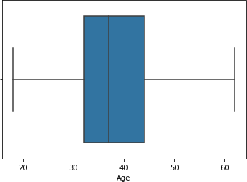

ds[ds["Age"]>ub]

Empty DataFrame

Columns: [RowNumber, CustomerId, Surname, CreditScore, Geography, Gender, Age, Tenure, Balance, NumOfProducts, HasCrCard, IsActiveMember, EstimatedSalary, Exited]

Index: []

# Check for Categorical columns and perform encoding

from sklearn.compose import ColumnTransformer from sklearn.preprocessing import OneHotEncoder ct=ColumnTransformer([('oh',OneHotEncoder(), [1,2])],remainder='passthrough') x=ct.fit_transform(x)

print(x.shape) (10000, 13)

import joblib joblib.dump(ct,"churnct.pkl")

['churnct.pkl']

# Split the data into training and testing

from sklearn.model_selection import train_test_split x_train,x_test,y_train,y_test = train_test_split(x,y,test_size=0.2,random_state=0) print(x_train.shape)

print(x_test.shape)

(8000, 13)

(2000, 13)

from sklearn.preprocessing import StandardScaler sc=StandardScaler() x_train=sc.fit_transform(x_train) x_test=sc.transform(x_test)

joblib.dump(sc,"churnsc.pkl") ['churnsc.pkl']